1. Diagrams Used For Mon Amour Dating Website
2. BPMN

BPMN stands for Business Process Modeling Notation. It is the new standard for modeling business processes and web service processes, as put forth by the Business Process Management Initiative (BPMN). BPMN is a core enabler of a new initiative in the Enterprise Architecture world called Business Process Management (BPMN). Business Process Management is concerned with managing change to improve business processes. So what we can illustrate in BPMN of Mon Amour Dating Website is because it is clear, easy to master layout, and unique algorithm.

1. Project Swim lane

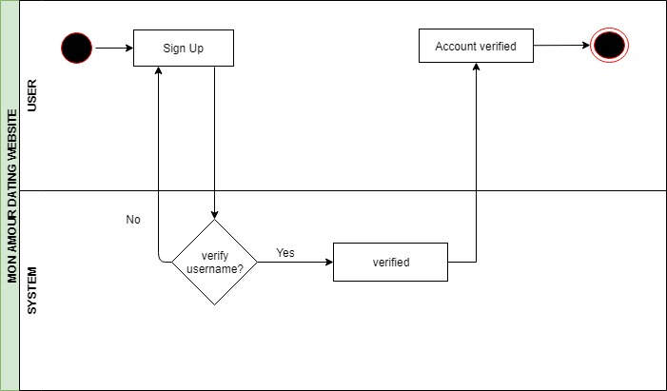

Figure 2.1 : Sign Up Swim Lane

Diagram above show about how the user want to sign up into the Mon Amour Dating Website. First lane is namely a user. And the second lane namely system. User will sign up into their profile and the system will verify the user username. If the system verified their username it will go to the account verified. And the process for sign up will end. If the system did not verifying the user username it will go back to sign up form.

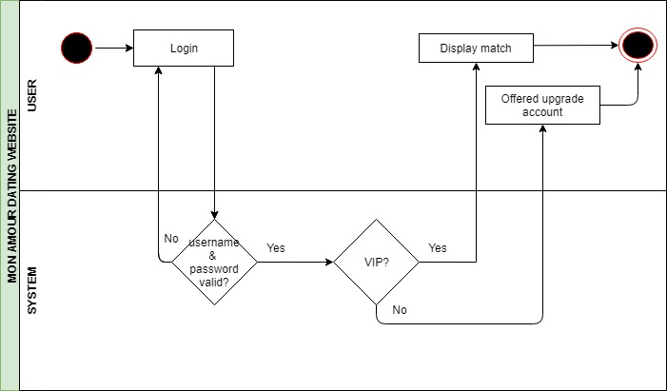

Figure 2.2 : Login Swim Lane

Diagram above show about how the user can login into the Mon Amour Dating Website. First lane is namely for user. And second lane is namely for system. User can login into the website after they have sign up their profile. Next, the system will validate the user username and password. And if it is already validate, the system will identify if the user already have VIP. If the system did not validate their username and password it will turn back into login form. If the user does not have VIP the system will offers to the account upgrade. Meanwhile, if the users already in VIP account the system will show the match of soul mate.

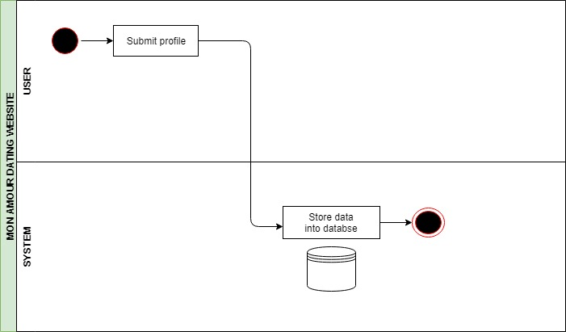

Figure 2.3 : Submit Profile Swim Lane

Diagram above show about how user can submit their profile into Mon Amour Dating Website. First lane is namely for user. And the second lane will namely for system. After user has already signed up into our Mon Amour Dating Website the system will store their confidential detail into the database.

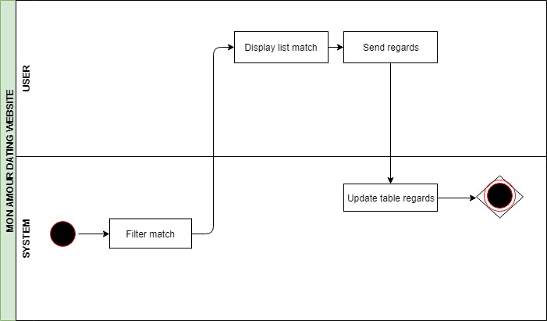

Figure 2.4: Match of soul mate Swim Lane

Diagram above is about how the system will do the match of soul mate for the user. The first lane is namely for system. And second lane is namely for user. The system will filter the match for the user and send it into user the display list match of soul mate. Moreover, user will sends regards into the chosen match. And lastly, the system will update the table regards.

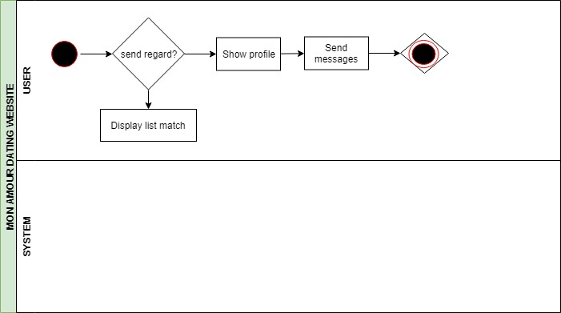

Figure 2.5 : Send Regard Swim Lane

Diagram above show about how user can send the regard into their selected match of soul mate. The lane that involve is only user. User will choose to sent regards or not. If user want to sent regard it will show the list of soul mate profile and user can sent message into the match. If they did not want to do so, it will only display into the list match only.

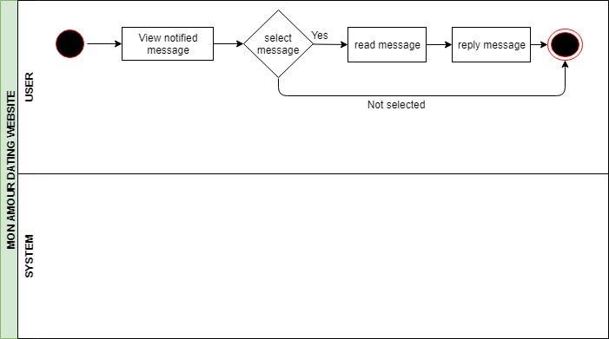

Figure 2.6 : Send Message Swim Lane

Diagram above show how the user can sent message in Mon Amour Dating Website. The lane that involve is only user. When user get message, he or she can view the notified message. If users select to view the message they can read the message and reply the message. If they don’t want to do so the flow will end.

1. 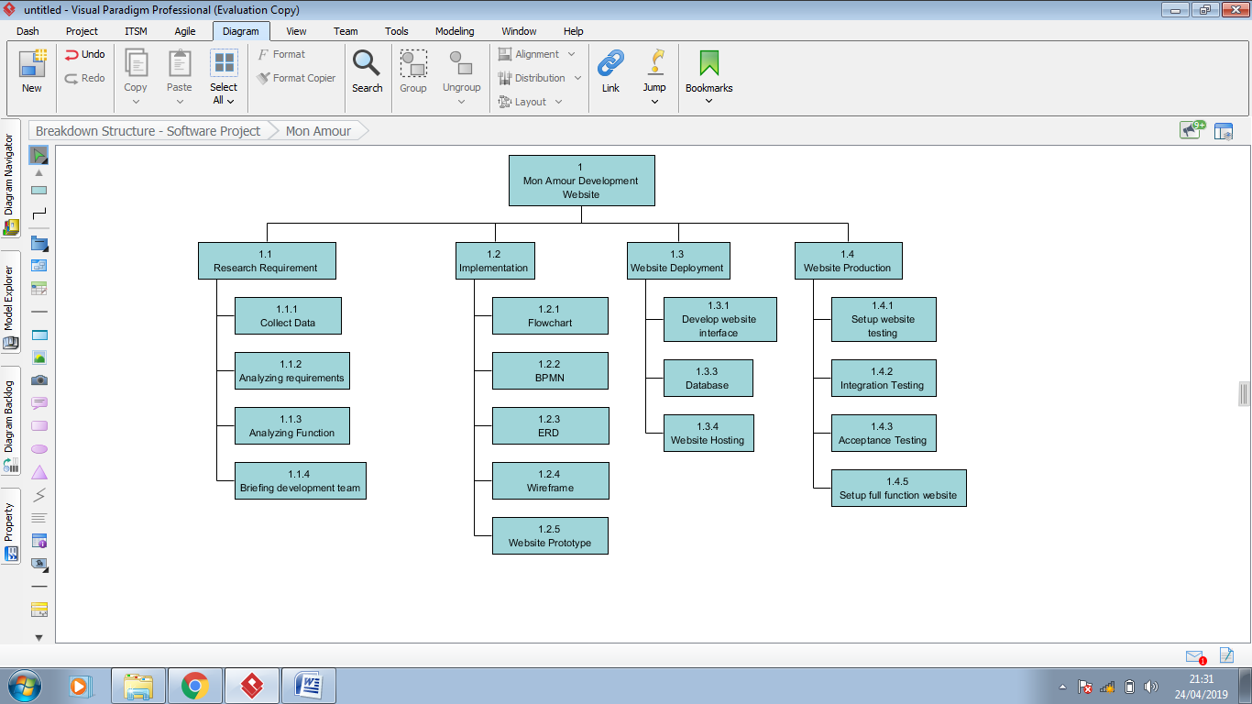Work Breakdown Structure

Figure 3.1 : WBS for Mon Amour Dating Website

A Work Breakdown Structure (WBS) may be a deterioration of all the work vital to total a venture. A WBS is organized in a progression and developed to permit for clear and coherent groupings, either by exercises or deliverables. The WBS ought to speak to the work recognized within the endorsed Project Scope Statement and serves as an early establishment for viable plan advancement and taken a toll evaluating. Extend supervisors ordinarily will create a WBS as a forerunner to a nifty gritty extend plan.

The objectives of creating a WBS are for the venture group to proactively and coherently arrange out the venture to completion. Other than that is to gather the information about work that has to be done for a venture and to organize exercises into sensible components that will accomplish extend destinations.

Database ERD

